**AEE 342: Aerodynamics, Project 1a – Analysis of Symmetric Airfoils**

**Submitted: 01/23/15**

The behavior of flow as it interacts with an object is an important field of study for many applications and is a fundamental element of the study of aerodynamics. It is common to describe such events by defining a vector velocity field known as a flowfield. In the problem being studied, the flowfield is described in terms of functions $u$ and $v$, describing the velocity of the flow in the $x$ and $y$ directions, respectively. Both $u$ and $v$ are time derivatives of their respective directional displacements, and are functions of both $x$ and $y$. As such, the flowfield is defined by

$$u\left(x, y\right)=\frac{s_{1}\left(x+1\right)}{{\left(x+1\right)}^{2}+y^{2}}+\frac{s_{2}x}{x^{2}+y^{2}}+\frac{s_{3}\left(x-1\right)}{{\left(x-1\right)}^{2}+y^{2}}+1$$

$$v\left(x, y\right)=\frac{s_{1}y}{{\left(x+1\right)}^{2}+y^{2}}+\frac{s_{2}y}{x^{2}+y^{2}}+\frac{s_{3}y}{{\left(x-1\right)}^{2}+y^{2}}$$

where $s_{1}=0.10$, $s_{2}=-0.07$, $s_{3}=-0.03$, and the flowfield is considered within the domain of $-4≤x≤4$ and $-3≤y≤3$. For this flowfield, the primary objective is to perform some analysis of the flow and its character, primarily through qualitative interpretation of various visualizations. Each visualization generated helps to convey different elements of the flow’s behavior, providing a cohesive interpretation as a whole. These visualizations with be described below.

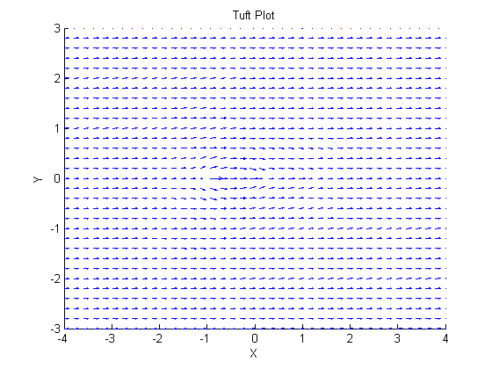 The plot shown here is known as a tuft plot. A tuft plot is useful because it contains information about both flow position and velocity, represented by vector arrows emanating from points $x,y$ with magnitudes proportional to $u, v$. A tuft plot is relatively intuitive to interpret because the information it contains appears in such a way that resembles a physical embodiment of flow. Several observations can be made about the flowfield by looking at this plot. The flow generally moves from left to right and remains largely undisturbed for the majority of the area under consideration. Some abrupt changes in direction and velocity can be seen near the center, suggesting that the flow has encountered some surface. A very short vector can be seen at the center of the y-axis and at the leading edge of the apparent disturbance. This suggests that a stagnation point may exist here, further reaffirming the notion that the flow has encountered a solid body.

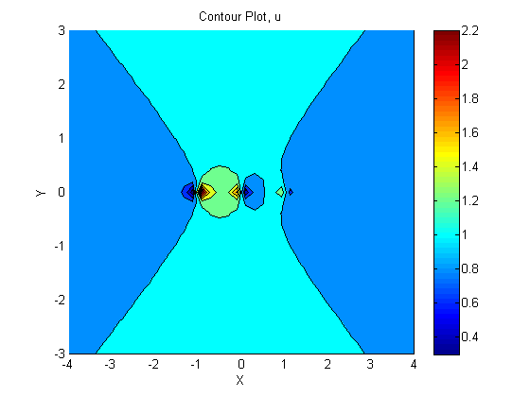 The next visualization generated is a contour plot. In total, 3 such plots are generated, representing $u, v, q$ velocity fields. 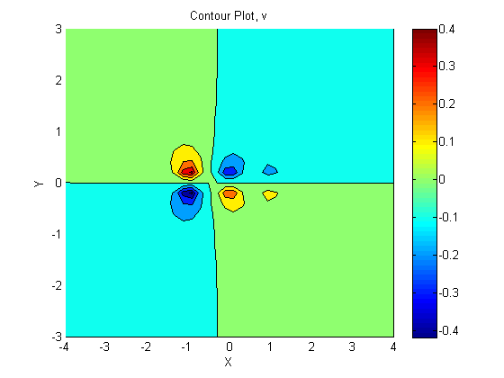Typically, contour plots are used for distinguishing parts of a map at different altitudes. This application is not very different from that found in the context of flowfield interpretation. A map shows the position of different elements in 2 dimensional $x,y$ space, with the gravitational potential, or height, of the points displayed by the contour. In the same way, a contour plot shows the flow’s velocity at different points, in this case with the use of colors. 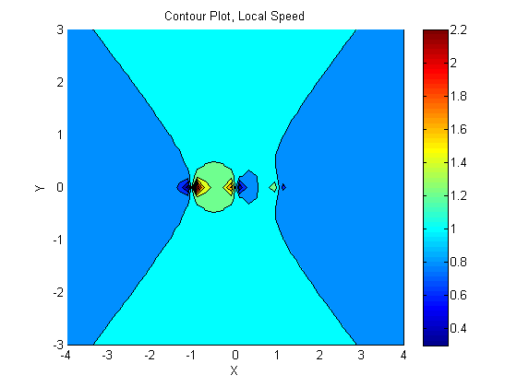 Here, the spectrum lies between blue being the slowest flow and red being the fastest. It should be noted, however, that the scale on these color ranges varies between plots. This explains why the colors of the plot for $v$ have such contrast, yet have little impact on the resultant flow. Here, some nuance can be observed that was not apparent in the tuft plot. It is clear that the solid body in the center of the flowfield is influencing the velocity of the flow far in advance, and that a linear relationship exists between how far to the side of the solid body the flow is and how soon it can begin to accelerate. The flow found in the center is most heavily influenced by the solid object, appearing to decelerate to a stop and then accelerate very quickly again, among other fluctuations. The contour plot for $v$ looks particularly unusual, but some sense can be made by considering how little the flow is moving in the first place. As such, an encounter with solid object is able to change the velocity sufficiently so that it may appear as a very drastic change in the contour plot. Again, the scale of the color distribution is important to consider here.

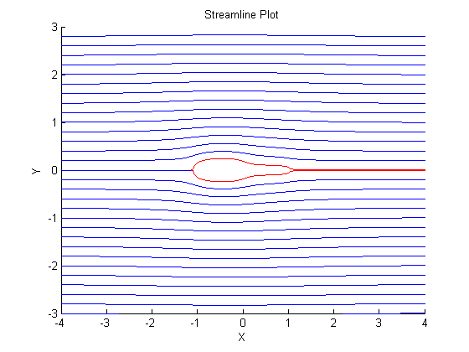 Perhaps one of the most revealing visualizations of the flow is the streamline plot. Here, streamlines are plotted, representing the path a given particle of the flow is expected to take under steady conditions. This looks similar to the tuft plot and also provides a true to lift visualization. These streamlines were plotted as the solution to the differential equations relating the position and velocity of the flow. Specifically, Euler’s Method was used to numerically solve for the paths that streamlines took when given arbitrary initial positions. Among the most powerful features of the contour plot comes from the fact that streamlines near the surface of the solid body in the flow reveal much about the shape of the object. In fact, this plot suggests that the flow is interacting with some symmetric airfoil, with part of the flow coming to stagnation at its leading edge.

The final plot generated is a velocity distribution for one of the surfaces of the airfoil. This is determined by first determining the extent of the airfoil using the streamline methods above, and then plotting the resultant speeds for each point along the boundary. This is useful because it begins to describe the potential performance of the airfoil. The dynamic pressure encountered by the airfoil is heavily influenced by the flow’s velocity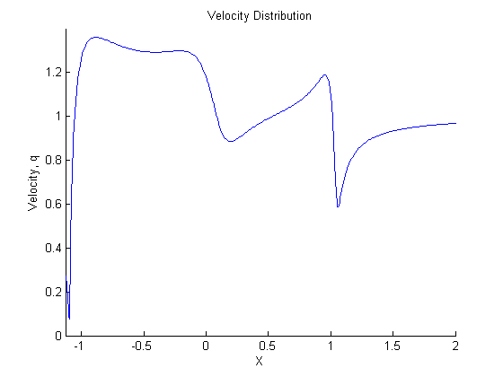. With this distribution, some predictions can be made about how the airfoil will interact with the freestream and whether pressure will generate more drag or lift.

Although this analysis is far from thorough, each visualization has contributed valuable insight into the problem and how it may be investigated further.

**Calculations**

%Joel Lubinitsky

%AEE 342 - Project 1a: Analysis of Symmetric Airfoils

%01/23/15

clear all

close all

clc

%% Known

%Flowfield Coefficients

s1 = 0.10;

s2 = -0.07;

s3 = -0.03;

%Domain

xMin = -4;

xMax = 4;

yMin = -3;

yMax = 3;

%Velocity Field

[x, y] = meshgrid(linspace(xMin, xMax, 40), linspace(yMin, yMax, 31));

u = s1 .* (x + 1) ./ ((x + 1) .^ 2 + y .^ 2) + s2 .* x ./ (x .^ 2 + y .^ 2) + s3 .* (x - 1) ./ ((x - 1) .^ 2 + y .^ 2) + 1;

v = s1 .* y ./ ((x + 1) .^ 2 + y .^ 2) + s2 .* y ./ (x .^ 2 + y .^ 2) + s3 .* y ./ ((x - 1) .^ 2 + y .^ 2);

%% Calculations

speedResultant = sqrt(u .^ 2 + v .^ 2);

[qMin, indexQMin] = min(speedResultant(16,:));

yStagnation = 0;

xStagnation = x(16, indexQMin);

%% Euler Loop

%Initialize Conditions

T = 10;

dt = 0.01;

N = (T / dt) + 1;

xy = zeros(N, 2);

%Run Loop

figure(5)

hold on

axis([xMin xMax yMin yMax])

title('Streamline Plot')

xlabel('X')

ylabel('Y')

for i = [1 : length(linspace(yMin, yMax, 30))]

xy(1, :) = [x(1), y(i)];

for n = [1 : N - 1]

xy(n + 1, :) = p1aEuler(xy(n, :), dt);

end

plot(xy(:, 1), xy(:, 2))

end

%Airfoil Streamlines

xyAirfoil = zeros(N, 2);

for i = [-0.001, 0.001]

xyAirfoil(1, :) = [xStagnation, i];

for n = [1 : N - 1]

xyAirfoil(n + 1, :) = p1aEuler(xyAirfoil(n, :), dt);

end

plot(xyAirfoil(:, 1), xyAirfoil(:, 2), 'color', [1 0 0])

end

%Velocity Distribution

qAirfoil = sqrt((s1 .* (xyAirfoil(:, 1) + 1) ./ ((xyAirfoil(:, 1) + 1) .^ 2 + xyAirfoil(:, 2) .^ 2) + s2 .* xyAirfoil(:, 1) ./ (xyAirfoil(:, 1) .^ 2 + xyAirfoil(:, 2) .^ 2) + s3 .* (xyAirfoil(:, 1) - 1) ./ ((xyAirfoil(:, 1) - 1) .^ 2 + xyAirfoil(:, 2) .^ 2) + 1) .^ 2 + (s1 .* xyAirfoil(:, 2) ./ ((xyAirfoil(:, 1) + 1) .^ 2 + xyAirfoil(:, 2) .^ 2) + s2 .* xyAirfoil(:, 2) ./ (xyAirfoil(:, 1) .^ 2 + xyAirfoil(:, 2) .^ 2) + s3 .* xyAirfoil(:, 2) ./ ((xyAirfoil(:, 1) - 1) .^ 2 + xyAirfoil(:, 2) .^ 2)) .^ 2);

figure(6)

hold on

axis([xStagnation 2 0 1.4])

title('Velocity Distribution')

xlabel('X')

ylabel('Velocity, q')

plot(xyAirfoil(:, 1), qAirfoil)

%% Plots

%Tuft Plot

figure(1)

hold on

quiver(x, y, u, v)

title('Tuft Plot')

xlabel('X')

ylabel('Y')

axis([xMin xMax yMin yMax])

%Contour Plot, u

figure(2)

hold on

contourf(x, y, u)

colorbar

title('Contour Plot, u')

xlabel('X')

ylabel('Y')

axis([xMin xMax yMin yMax])

%Contour Plot, v

figure(3)

hold on

contourf(x, y, v)

colorbar

title('Contour Plot, v')

xlabel('X')

ylabel('Y')

axis([xMin xMax yMin yMax])

%Contour Plot, Local Speed

figure(4)

hold on

contourf(x, y, speedResultant)

colorbar

title('Contour Plot, Local Speed')

xlabel('X')

ylabel('Y')

axis([xMin xMax yMin yMax])

**Functions**

%Joel Lubinitsky

%AEE 342 - Project 1a: Analysis of Symmetric Airfoils

%Euler Loop Function

%01/23/15

function xyNext = p1aEuler(xy, dt)

uv = zeros(1, 2);

xyNext = zeros(1, 2);

s1 = 0.10;

s2 = -0.07;

s3 = -0.03;

x = xy(1);

y = xy(2);

uv(1) = s1 .* (x + 1) ./ ((x + 1) .^ 2 + y .^ 2) + s2 .* x ./ (x .^ 2 + y .^ 2) + s3 .* (x - 1) ./ ((x - 1) .^ 2 + y .^ 2) + 1;

uv(2) = s1 .* y ./ ((x + 1) .^ 2 + y .^ 2) + s2 .* y ./ (x .^ 2 + y .^ 2) + s3 .* y ./ ((x - 1) .^ 2 + y .^ 2);

xyNext(1) = uv(1) .* dt + x;

xyNext(2) = uv(2) .* dt + y;

end

**Plots**













**References**

Matlab Documentation. <http://www.mathworks.com/help/matlab/>.